Screenshot references:

### lint, coverage, and test reports ##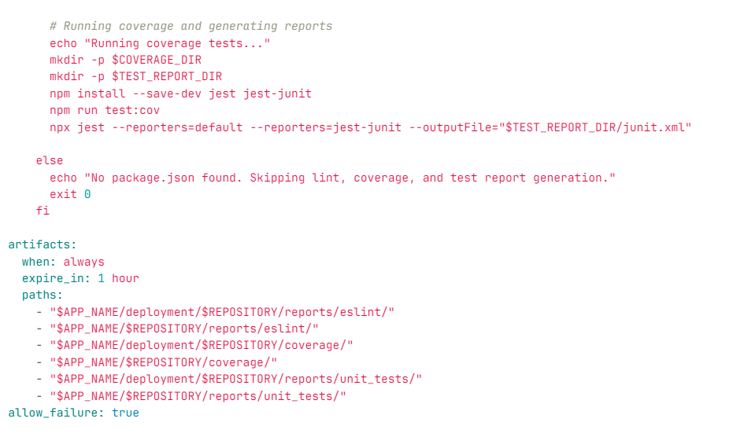

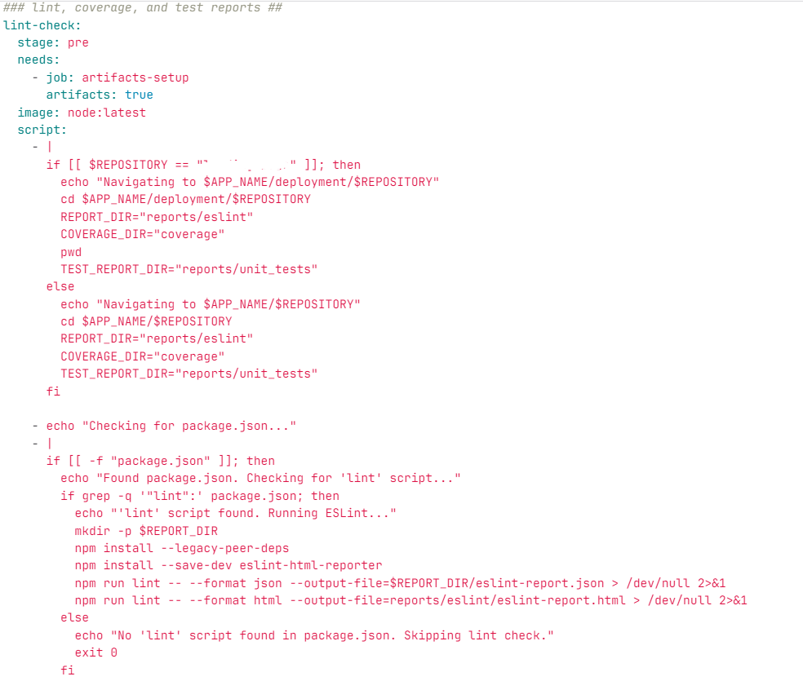

Sonar Stage:

Make sure the path where reports are getting store should be passed to sonar as report path.

1. **Generated Reports**:
   * **Linting**: ESLint reports (eslint-report.json, eslint-report.html) in reports/eslint/.
   * **Unit Tests**: JUnit XML (junit.xml) in reports/unit_tests/.
   * **Coverage**: LCOV (lcov.info) in coverage/.
2. **Stored Reports**: Saved these reports in directories like reports/ and coverage/.
3. **Passed to SonarQube**:
   * Set report paths in sonar-project.properties or pipeline's Sonar scanner step:
4. - sonar-scanner
5. -Dsonar.javascript.lcov.reportPaths=coverage/lcov.info
6. -Dsonar.eslint.reportPaths=reports/eslint/eslint-report.json
7. -Dsonar.junit.reportPaths=reports/unit_tests/junit.xml
8. -Dsonar.working.directory=$CI_PROJECT_DIR

**Integrated with CI**: Used Sonar scanner in the pipeline to analyze the code and push reports.

**Debugging Steps:**

1. **Check Report Generation**:
   * Verify that reports are generated and stored in the correct directories:

bash

Copy code

ls -l reports/eslint/

ls -l reports/unit_tests/junit.xml

ls -l coverage/lcov.info

1. **Validate Paths in Pipeline**:
   * Ensure the correct paths are passed in the Sonar scanner step:

yaml

Copy code

sonar.javascript.lcov.reportPaths=coverage/lcov.info

sonar.testExecutionReportPaths=reports/unit_tests/junit.xml

1. **Run Sonar Scanner with Debugging**:
   * Add -X to the Sonar scanner command to see detailed logs:

bash

Copy code

sonar-scanner -X

1. **Verify SonarQube Dashboard**:
   * **Coverage**: Check the "Coverage" tab for code coverage percentage.
   * **Unit Tests**: Check "Measures" for test execution results.
   * **Issues**: Verify linting issues under "Issues".
   * **Duplications**: Check duplications under the "Code" tab.
2. **Fix Missing Reports**:
   * If reports are missing, ensure:
     + Correct REPORT_DIR, COVERAGE_DIR, and TEST_REPORT_DIR are used.
     + Reports are not overwritten or cleared during pipeline steps.
   * Debug with echo or ls to confirm paths.